[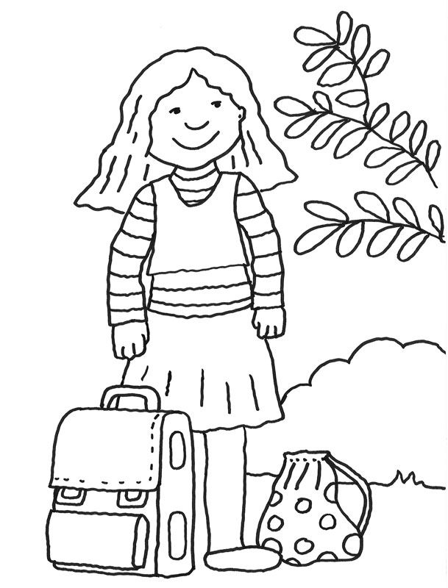](https://www.google.com/url?sa=i&url=https://www.pinterest.de/pin/860187597547343447/&psig=AOvVaw1a4GwfDpeqgLSMtP0fA8nE&ust=1588156743420000&source=images&cd=vfe&ved=0CAIQjRxqFwoTCNCwi4f3iukCFQAAAAAdAAAAABAE)

[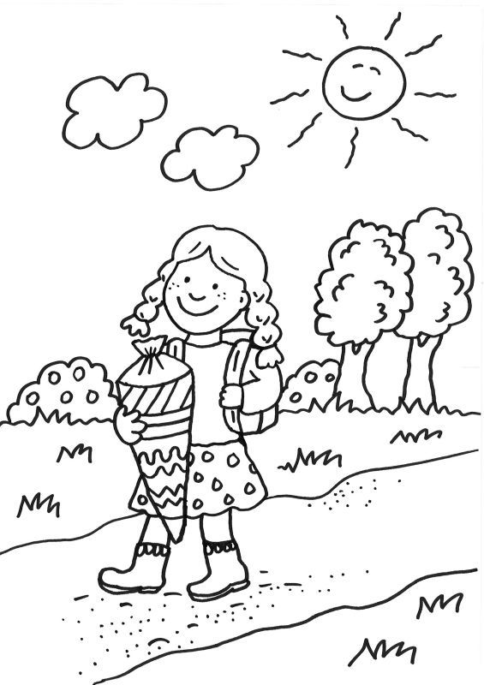](https://www.google.com/url?sa=i&url=https://www.pinterest.de/pin/101190322857039699/&psig=AOvVaw1a4GwfDpeqgLSMtP0fA8nE&ust=1588156743420000&source=images&cd=vfe&ved=0CAIQjRxqFwoTCNCwi4f3iukCFQAAAAAdAAAAABAL)

[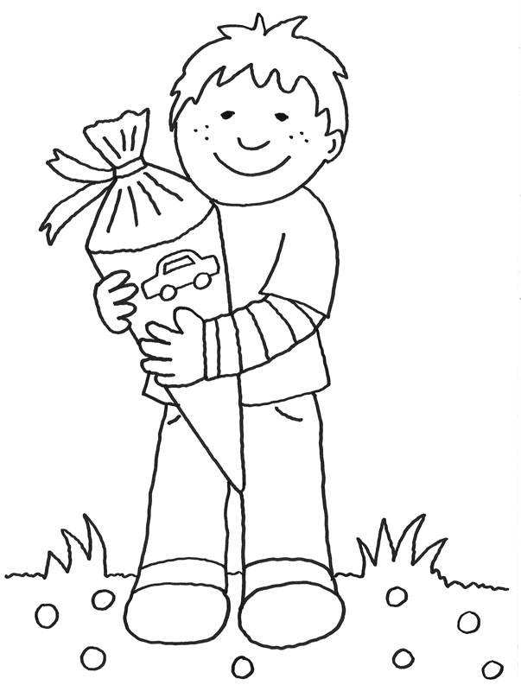](https://www.google.com/url?sa=i&url=https://www.schule-und-familie.de/ausmalbild-drucken/junge-freut-sich.html&psig=AOvVaw1a4GwfDpeqgLSMtP0fA8nE&ust=1588156743420000&source=images&cd=vfe&ved=0CAIQjRxqFwoTCNCwi4f3iukCFQAAAAAdAAAAABAR)

[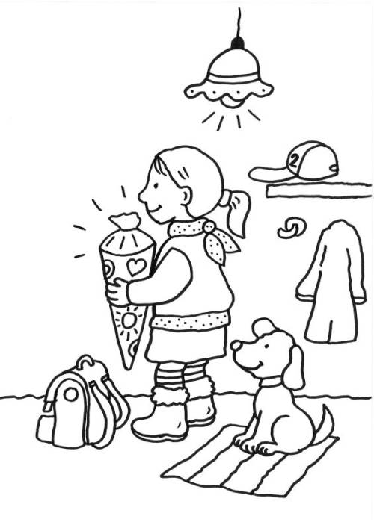](https://www.google.com/url?sa=i&url=https://www.schule-und-familie.de/malvorlagen/einschulung/maedchen-am-ersten-schultag-ausmalen.html&psig=AOvVaw1a4GwfDpeqgLSMtP0fA8nE&ust=1588156743420000&source=images&cd=vfe&ved=0CAIQjRxqFwoTCNCwi4f3iukCFQAAAAAdAAAAABAW)

[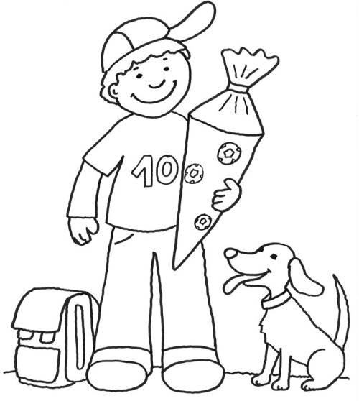](https://www.google.com/url?sa=i&url=https://www.malvorlagenandcoloring.com/malvorlage-madchen-mit-schultute/&psig=AOvVaw1a4GwfDpeqgLSMtP0fA8nE&ust=1588156743420000&source=images&cd=vfe&ved=0CAIQjRxqFwoTCNCwi4f3iukCFQAAAAAdAAAAABAb)

[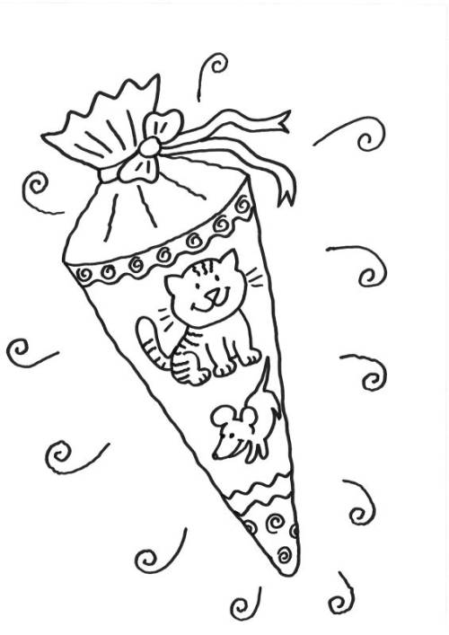](https://www.google.com/url?sa=i&url=https://www.schule-und-familie.de/malvorlagen/einschulung/schultuete-katze-maus-motiv-ausmalen.html&psig=AOvVaw1a4GwfDpeqgLSMtP0fA8nE&ust=1588156743420000&source=images&cd=vfe&ved=0CAIQjRxqFwoTCNCwi4f3iukCFQAAAAAdAAAAABA_)

[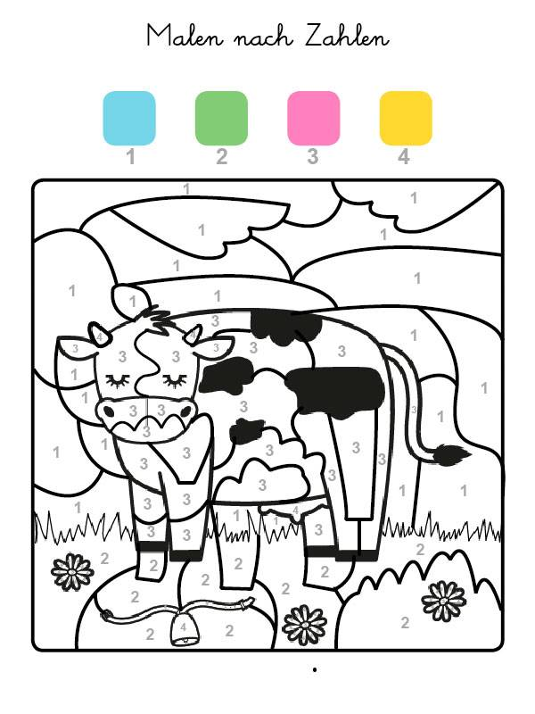](https://www.google.com/url?sa=i&url=https://www.schule-und-familie.de/ausmalbild-drucken/kuh-ausmalen.html&psig=AOvVaw1UgaMVDh-IMWTtWTLhCSVI&ust=1588161735297000&source=images&cd=vfe&ved=0CAIQjRxqFwoTCNj2xdOJi-kCFQAAAAAdAAAAABAa)

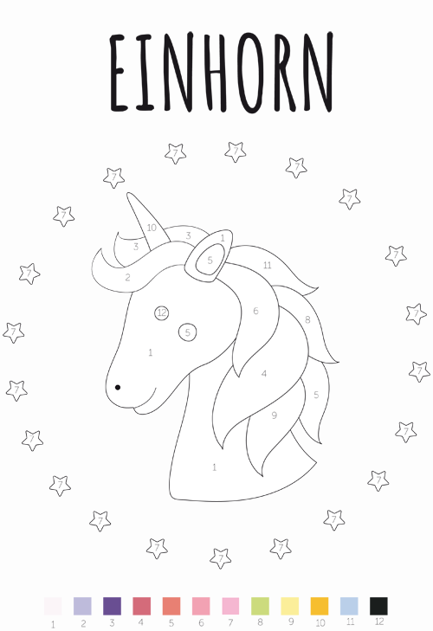

[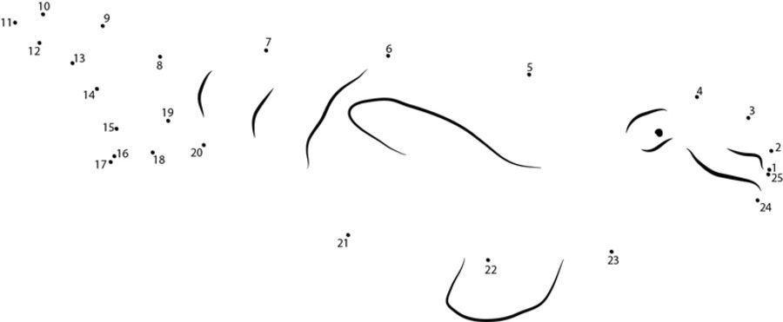](https://www.google.com/url?sa=i&url=https://printmania.online/de/punkt-zu-punkt/wal/&psig=AOvVaw0ml2rY2NFa26ywInSROqru&ust=1588162599094000&source=images&cd=vfe&ved=0CAIQjRxqFwoTCKjUuu-Mi-kCFQAAAAAdAAAAABAF)